TRACKING MY LEARNING |  |  |  |  | Name:
Priority  Standard | 5.NO.CC.1– Read and write decimals to the thousandths including standard, word, and expanded forms.
Where am I at in my learning? |  |  | 1  With help |  | 2  With reminders |  | 3  on my own | 4  teach others
I can read and write decimals in standard (2.2), word (two and two tenths), and expanded form ((2 x 1) + (2 x 0.1)).

Complete Navvy Practice Check CC.1 with 88% accuracy.
Date: |  |  |  | Percentage Correct:
How will I SHOW my learning? Choose 2
Choice 1 |  | Choice 2 |  |  |  | Choice 3
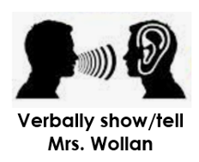 |  |   Seesaw Assessment |  |  |  | 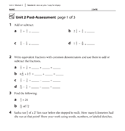  Paper Assessment
Conference Notes
Were there any problems that felt tricky at first? How did you work through it?

What part of this skill do you feel most confident about?

How would you explain this skill to another student?

